**Your Place for Food, Fun and Friendship!**

**September 2024 – Labor Day Party**

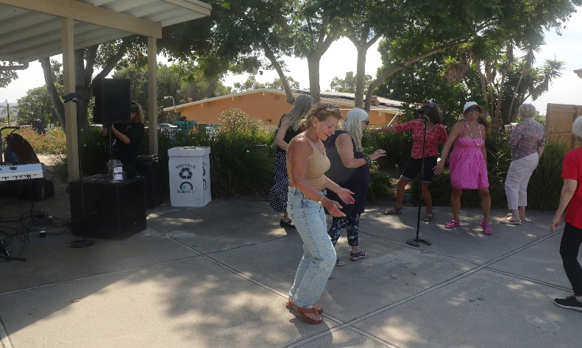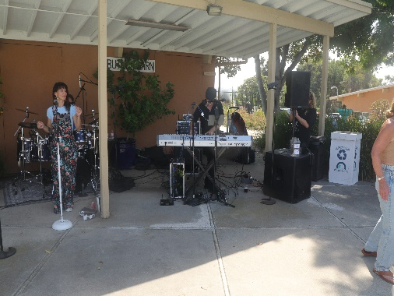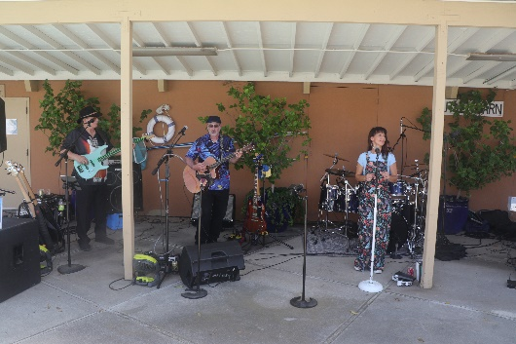

On a wonderful sunny September day, Oceana had over 140 people in attendance for our Labor Day Party. The food was excellent with several varieties of chicken wings, baked beans, pasta and Caesar salad. The great entertainment was the Cool Rush Band. They played almost nonstop for around 2 hours with great vocals and instrumentation from their 5-piece band. Many attendees were up dancing to their great music and asked for a couple of encores because they were having so much fun.

**August 2024 – Activities Events**

August was another busy Month for Activities. Check out some of the events below!

**Ice Cream Social**

On a wonderful August, Saturday afternoon we had Ice Cream sundaes, Root beer Floats and loads of fun for everyone... and it was FREE!! Anton the juggler (and chair balancing) provided the entertainment.

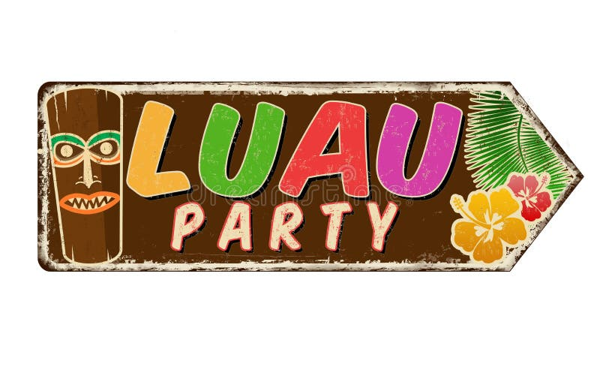**Poolside Luau**

After missing several years, Oceana hosted a Luau for our residents. Pulled pork sliders, shredded jerk sliders, mac ‘n cheese, grilled pineapple, and special “Blue Hawaiian” drinks were available. “Lea Love” provided Hawaiian music. Lea Love is an Oceanside native, and we were happy to hear that she and her partner had just gotten married the week before!  The Activities Committee volunteers dressed up the pool area with leis and grass skirts.  What fun!

**Afternoon Treat**

A “Fifth Thursday” in August had an 2 pm “Afternoon Treat” instead of the traditional morning Coffee Hour. This month we had a light snack of chicken skewers, fruit and sodas. This was complemented by our great musical entertainment combo of Jimmy and Enrique. They had us “dancing in the hall”.

**August Coffee Hour**

Coffee Hour in August had another great month of different presentations and entertainment.

Thursday morning Coffee Hour events start between 8:30 and 9:30 am when you pick up a beverage (yes, we also offer sodas) and food of choice (only $1 each). At 9:30 announcements of upcoming events at Oceana are provided (plus some fun stories and a few jokes). At 9:45 the visiting entertainers and fun begins. Please join us on Thursdays if you can. The following are the great events and entertainers we had this past month.

**Bingo**

“Knock, knock!” “Who’s there?” “B, I.” “B, I, Who?” “B, I, N, G, O! B, I, N, G, O! B, I, N, G, O! and Bingo was his Name-OH!” Ellen Marciel called several rousing games of Bingo this past month. Traditional, Square, “B’s” only and finishing with “Black Out” games. Lots of prizes for our winners again. It’s a great activity for us as “Seniors” to help build our “Hand-Eye” coordination. Come and join us on most 1st Thursdays of the month!

**Susie Lotzof**

Susie Lotzof was back again this year. She did not disappoint us with her singing and storytelling. (e.g. Her twin sister being left-handed, but she was right-handed... always “right”).

She sang many popular songs and got some folks to join her up on the stage to dance during one of her numbers. Susie provided “lots of” fun for us.

**Robert Parker**

Robert again “Blessed Us” with improvisational magic on the piano and wonderful stories. He says each time he plays a song... it is always new, because he never knows what will come out of his hands. He told a fun story about being a bus driver and almost falling asleep in his younger days. It’s always magical when he comes to entertain.

**Adrienne Nims**

Adrienne has such great energy and mastery of her woodwind instruments. She is the premier flautist in the San Diego area. She has an amazing repertoire of music for all occassions. She always puts on a great show for us!